Project Pre-Requisites

|  |  |
| --- | --- |
| Date | 12 November 2022 |
| Team ID | PNT2022TMID10381 |
| Project Name | Machine Learning based Vehicle Performance Analyzer |

1. First install Anaconda software.
2. Then in Anaconda Navigator download Jupyter Notebook.

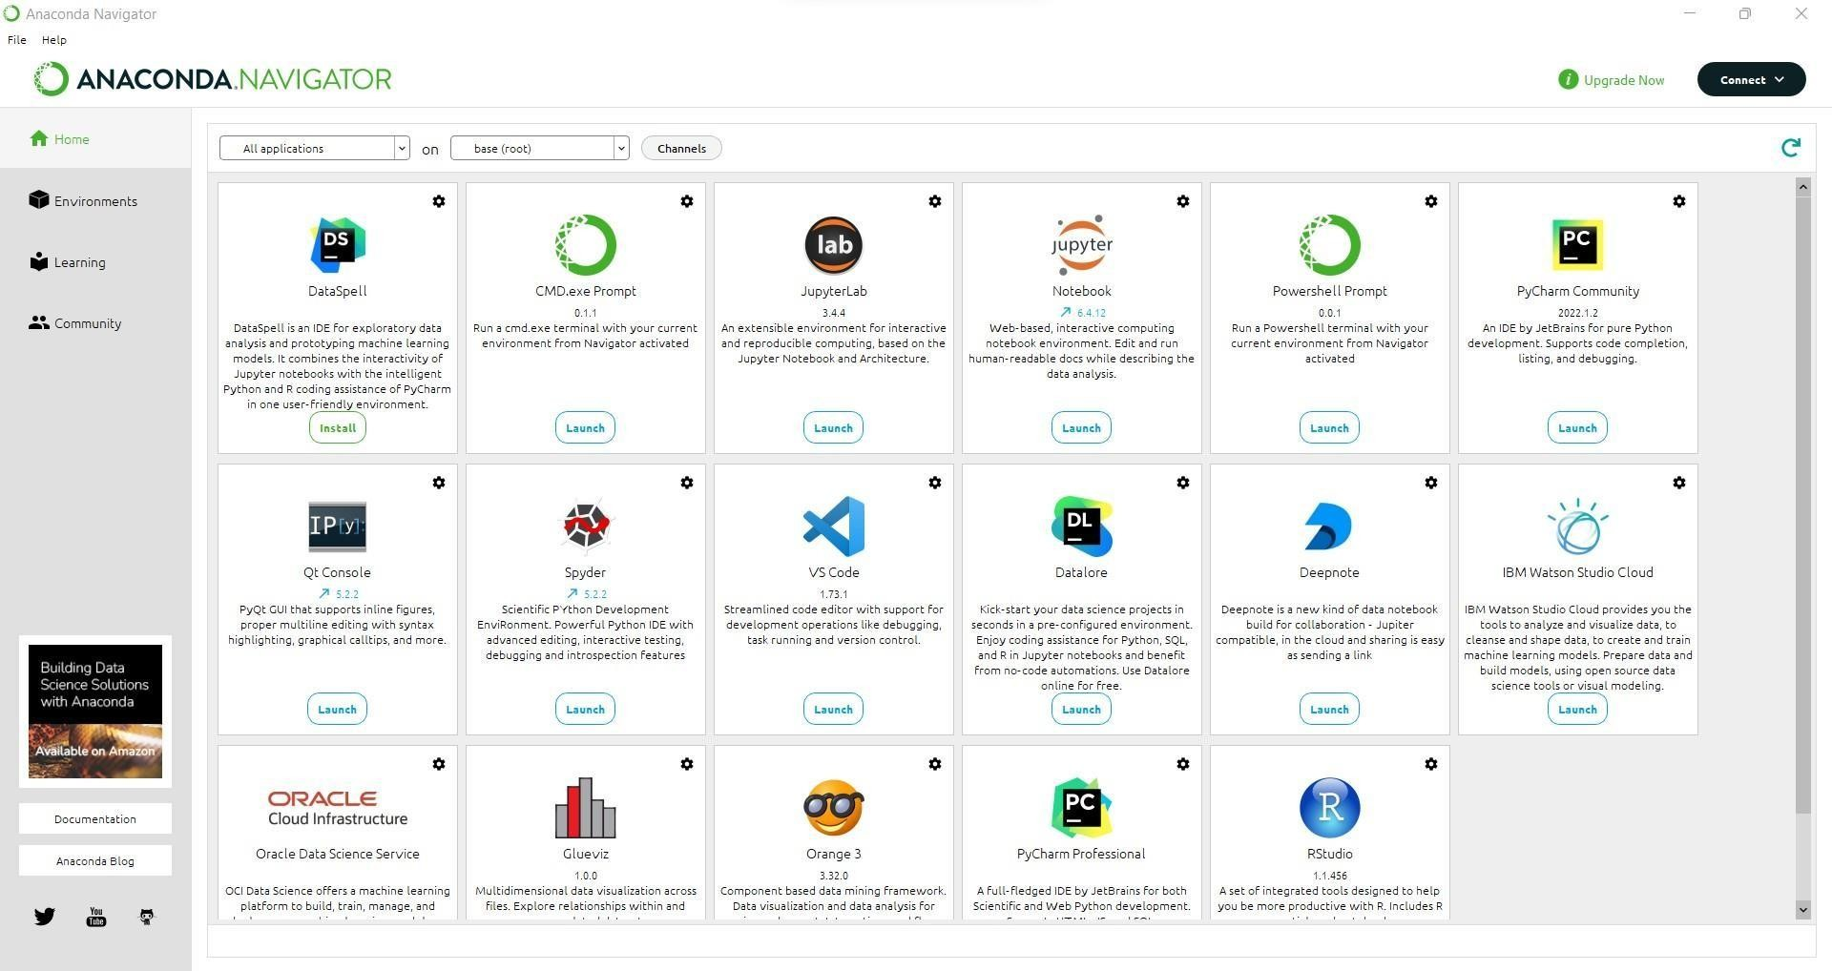

1. Install Python packages

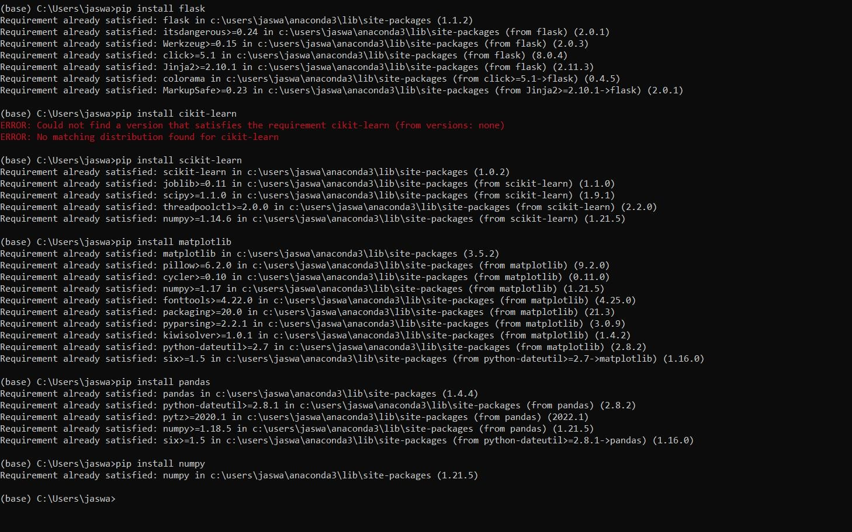

The following packages are installed

* + Flask
  + Scikit-learn
  + Matplotlib
  + Pandas
  + Numpy